The Fundamental Security Concepts in AWS

The Shared Responsibility Model
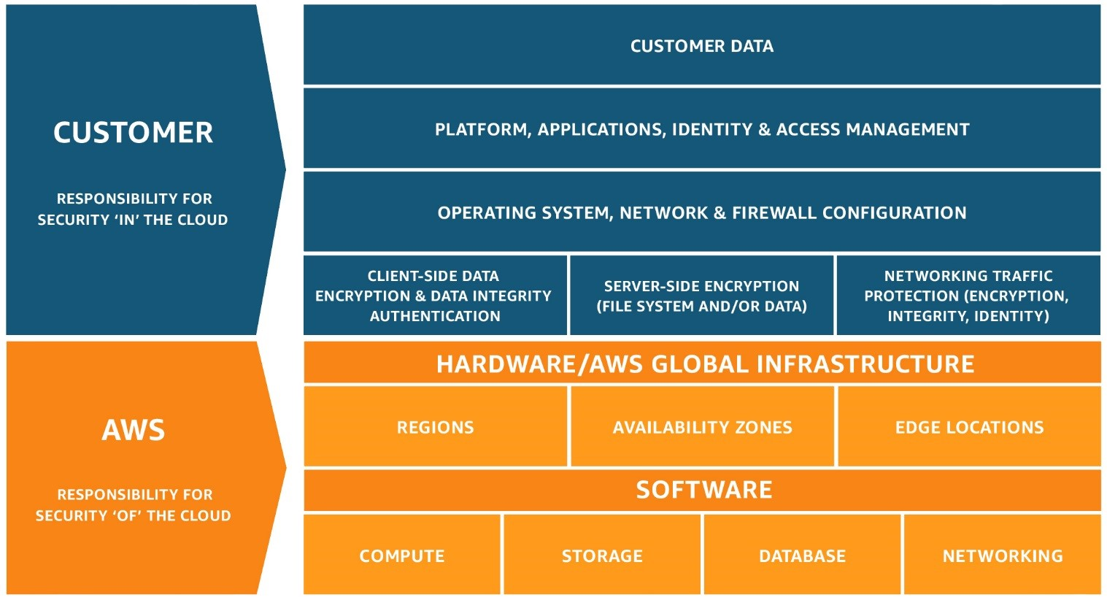
When you begin working in AWS, the most important security (and, to a certain point, operational) principle that you must understand is who is responsible for what. Who is accountable for patching the OS? Who is responsible for encrypting data-at-rest? Who is accountable for application security? Who is liable for regulatory compliance? As it turns out, you are -- for all of these.
Under the AWS shared responsibility model, AWS provides a global secure infrastructure and foundation compute, storage, networking and database services. Essentially, everything up to and including the hypervisor is the responsibility of AWS. You, the client, are responsible for protecting the confidentiality, integrity, and availability of your data in the cloud, and for meeting specific business and compliance requirements.
The shared responsibility model for infrastructure services, such as Amazon Elastic Compute Cloud (Amazon EC2), for example, specifies that AWS manages the security of the following assets:
- Facilities
- Physical security of hardware
- Network infrastructure
- Virtualization infrastructure
In the case of Amazon EC2, for example, you as the customer are responsible for the security of the following assets:
- Operating systems
- Applications
- Data in transit
- Data at rest
- Data stores
- Credentials
- Policies and configuration
Securing your environment in AWS can be complicated simply because of the large number of native security controls that AWS provides, and because of the interactions between many of these controls. The diagram below is one visualization of the number and types of AWS security controls and their relationships.
In order to simplify this, we have broken this down into five security pillars. We chose to present these concepts in this manner because it naturally mimics the five pillars that define the AWS Well-Architected Framework.

The Five Major AWS Security Pillars
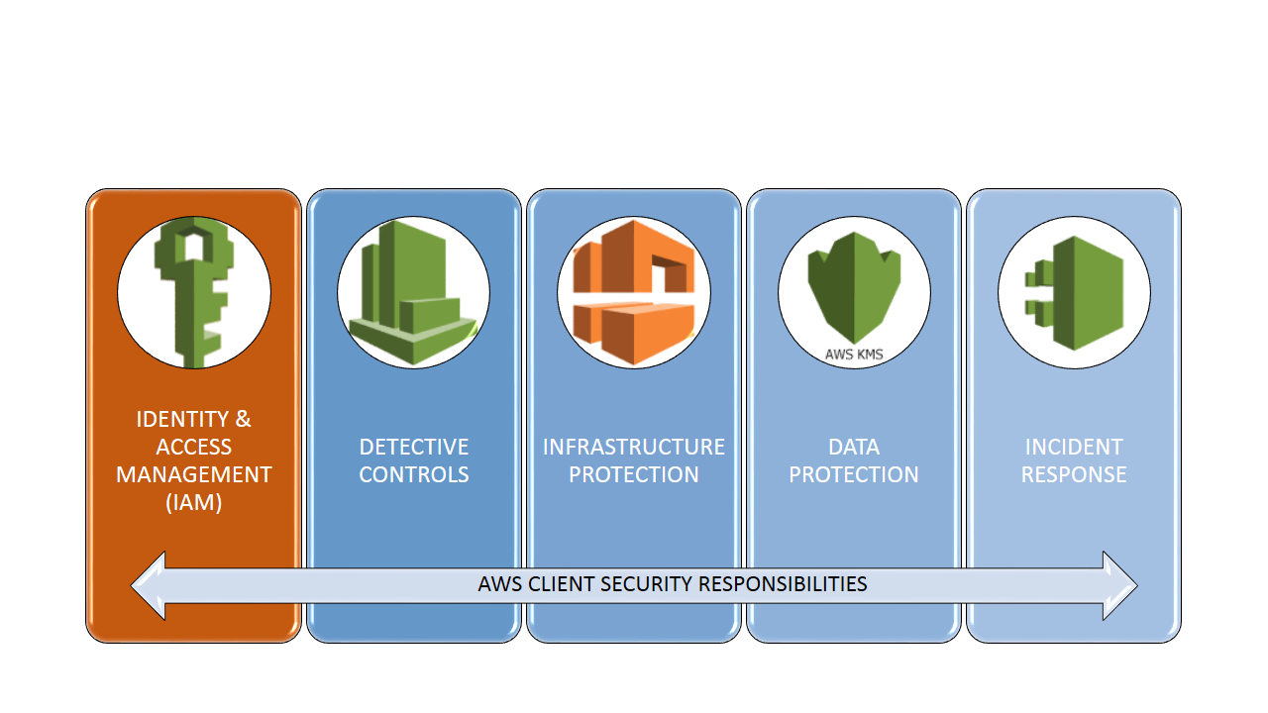

IAM
IAM is all about Identity:
- Users
- Groups
- Roles
- Policies
This section describes IAM identities, which you create to provide authentication for people and processes in your AWS account. This section also describes IAM groups, which are collections of IAM users that you can manage as a unit. Roles are usually temporary and service-specific. Roles can be authenticated and then authorized to perform specific actions in AWS. Each of these entities can be associated with one or more policies to determine what actions a user, role, or member of a group can do with which AWS resources and under what conditions.
All of this can be very complicated and it is easy to do incorrectly.

The AWS Account Root User
When you create your first AWS account, you create an account (or root user) identity, which you use to sign in to AWS. Note that when you create your first AWS account, you will need to provide a credit card even though individuals who use AWS as a test environment often don't accrue any costs. You first sign in to the AWS Management Console as the root user using the email address and password that you provide when you create the account. This combination of your email address and password defines your root user credentials.
When you sign in as the root user, you have complete, unrestricted access to all resources in your AWS account, including access to your billing information and the ability to change your password. This level of access is necessary when you initially set up the account. However, AWS recommends that you don't use root user credentials for everyday access. It is not possible to restrict the permissions that are granted to the AWS root account. Instead, AWS strongly recommends that you adhere to the best practice of using the root user only to create your first IAM user and then securely locking away the root user credentials.
An additional best practice – both for Root accounts and for IAM users is to use two-factor authentication (2FA). 2FA should always be used for AWS authentication. A common solution is to use the virtual 2FA application, Authy. Authy is free, TOTP compliant, easy to configure, and works on both iOS and Android smartphones.

IAM Users
An IAM user is an entity that you create in AWS. The IAM user usually represents a person but can also refer to a service who uses the IAM user account to interact with AWS. A primary use for IAM users is to give people the ability to sign in to the AWS Management Console for interactive tasks and to make programmatic requests to AWS services using the API. A user in AWS consists of a name, a password to sign into the AWS Management Console, and up to two access keys that can be used with the API. When you create an IAM user, it makes sense to grant that account permissions by making it a member of the appropriate group that has appropriate permission policies attached. You can also clone the permissions of an existing IAM user, which automatically makes the new user a member of the same groups and attaches all the same policies.

IAM Groups
An IAM group is a collection of IAM users. The AWS concept of a group is a familiar one -- similar to groups in AD or UNIX. You can use groups to specify permissions for a collection of users, which can make those permissions easier to manage. For example, you could have a group called Admins and give that group all of the permissions that administrators typically need. Any user in that group automatically has the permissions that are assigned to the group. If a person changes jobs in your organization, instead of editing that user's permissions, you can remove him or her from the old groups and add him or her to the appropriate new groups. Note that a group is not truly an identity because it cannot be identified as a Principal in a resource-based or trust policy (more on policies later). Groups are the means to attach policies to multiple users at one time.

IAM Roles
IAM roles are typically the hardest IAM concept for new users to grasp. An IAM role is similar to a user, in that it is an AWS identity with permission policies that determine what the identity can and cannot do in AWS. However, instead of being uniquely associated with one person, a role is intended to be assumable by anyone or any service that needs it.
Also, a role does not have standard long-term credentials (password or access keys) associated with it. Instead, if a user or service assumes a role, temporary security credentials are created dynamically and provided to the user. An IAM user can assume a role to temporarily take on different permissions for a specific task. A role can be assigned to a federated user who signs in by using an external identity provider such as Facebook or Google. AWS uses details passed by the identity provider to determine which role is mapped to the federated user.
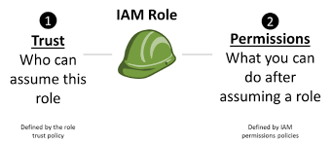
Applications that run on an Amazon EC2 instance need credentials in order to access other AWS services. To provide credentials to the application in a secure way, use IAM roles. A role is an entity that has its own set of permissions but isn't a user or group. Roles also don't have their own permanent set of credentials the way IAM users do. In the case of Amazon EC2, IAM dynamically provides temporary credentials to the EC2 instance to, for example, access an S3 bucket, and these credentials are automatically rotated for you.

Temporary Credentials
Temporary credentials are primarily used by IAM roles, but there are also other uses. You can request temporary credentials that have a more restricted set of permissions than your standard IAM user. This prevents you from accidentally performing tasks that are not permitted by the more restricted credentials. A benefit of temporary credentials is that they expire automatically after a set period of time. You have control over the duration that the credentials are valid.

IAM Policies
A policy is a JSON document in AWS that, when attached to an identity or resource, defines their permissions. AWS evaluates these policies when a principal, such as a user or a role, makes a request. Permissions in the policies determine whether the request is allowed or denied. Policies are stored in AWS as JSON documents attached to principals as identity-based policies, or to resources as resource-based policies. AWS provides hundreds of “canned” policies that support common scenarios.
The difficulty with policies isn't really the concept or the anatomy. Instead, it's the overwhelming number of possible actions, principals, resources, and conditions that we can insert into them. Additionally, the "context" of the policies (i.e. using them on an S3 bucket vs. an IAM user) also changes what can be inserted into them.
A good practice is to begin with the end in mind. Literally ask yourself and team: Who is allowed to do what to which resources at what times. List those answers out in a pseudo code and then search for a canned AWS policy or create a policy that fulfills those requirements.

Testing IAM Policies With the IAM Policy Simulator
Note that you must be logged into your AWS account to access the simulator. With the IAM policy simulator, you can test and troubleshoot IAM and resource-based policies in a number of ways.
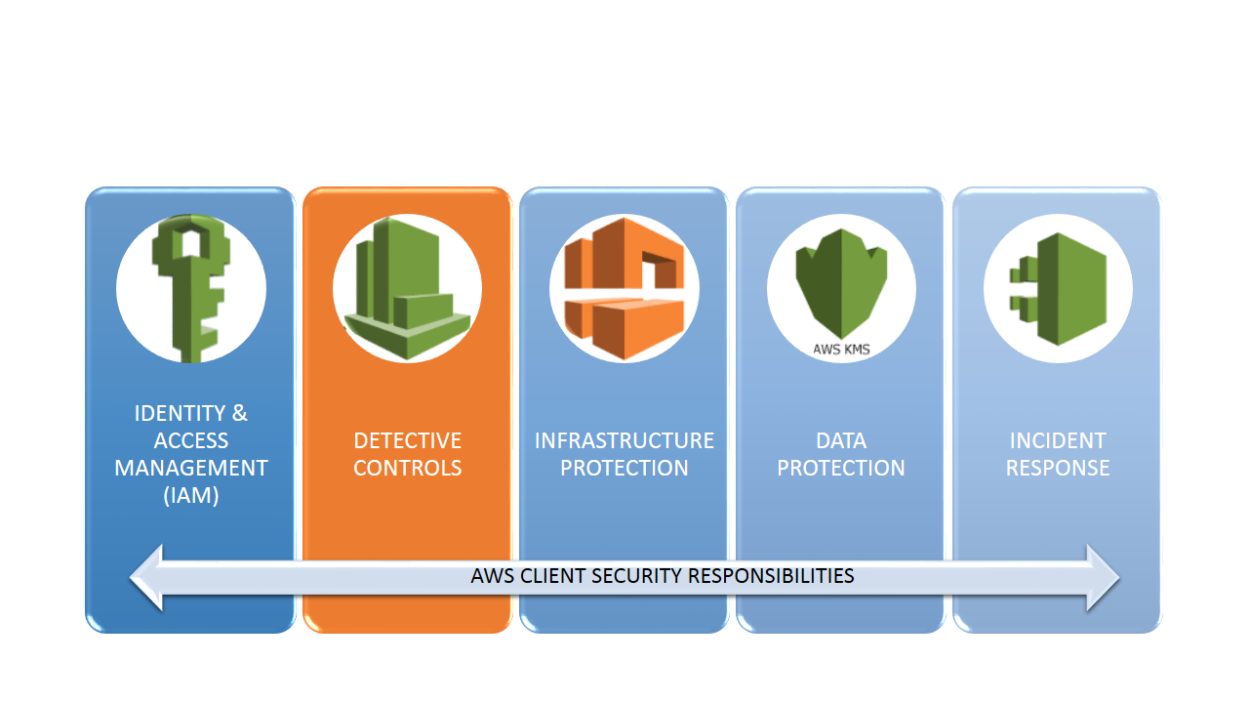

Detective Controls

Monitor Everything in Your AWS Account
You can use logging features in AWS to determine the actions users have taken in your account and the resources that were used. The log files show the time and date of actions, the source IP for an action, which actions failed due to inadequate permissions, and more.
These are some of the keylogging features available in AWS. Others will be discussed in subsequent sections.
- Amazon CloudWatch – Arguably the most important monitoring solution in AWS, CloudWatch monitors your AWS Cloud resources and the applications you run on AWS. You can set alarms in CloudWatch based on metrics or thresholds that you define that you define.

Sample CloudWatch Console Screenshot
- AWS CloudTrail logs every AWS API call and related events made by or on behalf of an AWS account.
- Amazon CloudFront logs user requests that CloudFront receives. Moreover, CloudFront provides mechanisms for secure distribution data and monitoring of those data flows.
- AWS Config provides detailed historical information about the configuration of your AWS resources, including your IAM users, groups, roles, and policies. For example, you can use AWS Config to determine the permissions that belonged to a user or group at a specific time.
- AWS Service Catalog allows IT administrators to create, manage, monitor, and distribute portfolios of approved products to end users, who can then access the products they need in a personalized portal. Typical products include servers, databases, websites, or applications that are deployed using AWS resources (for example, an Amazon EC2 instance or an Amazon RDS database). You can control which users have access to specific products to enforce compliance with organizational business standards and to manage product lifecycles.
- AWS Trusted Advisor AWS Premium Support plans include access to the Trusted Advisor tool, which offers a one-view snapshot of your service and helps identify common security misconfigurations, suggestions for improving system performance, and underutilized resources.
- Amazon GuardDuty uses integrated threat intelligence such as lists of known malicious IP addresses, anomaly detection, and machine learning to identify activity associated with threats, such as compromised EC2 instances mining Bitcoin or an attacker scanning your web servers for known application vulnerabilities. It also monitors AWS account access behavior for signs of compromise, such as detecting an atypical instance type deployed by a user from an unusual geo-location, or an attempt to disable CloudTrail logging or to snapshot a database from a suspicious IP address.

Conclusion
AWS is a good partner. They take care of their responsibilities and expect you to do the same. To this end, AWS offers a staggering number of tools and services to support their clients' security efforts.
Having strong authentication and authorization controls and automating responses to security events is clearly the future of security controls. In part two, I'll discuss the other three AWS security pillars that describe how you can protect infrastructure at multiple levels, protect data, both at rest and in transit, manage and classify data with resource tags and encryption, and how to automate incident response.
Many people and organizations are surprised at how much responsibility for security in AWS falls to them. I believe that AWS got it exactly right with this.
Imagine for a moment that AWS decided that it was responsible for the security of all data that it stores, uses, or transmits across its network and that AWS required you or your organization to delegate all of your data security to an AWS security black-box. That would not make me feel all warm and fuzzy. In fact, I would not trust a third party to secure the critical data assets of my organization. As you saw in Part 1 of this series, and as you'll see in Part 2 as well, AWS provides a wide range of compliance, monitoring, and encryption services that enable any organization to secure its critical data assets in the cloud. I would argue that I am able to secure data in AWS more simply and more thoroughly than I can with on-premises data.
In Part 1, we looked at two of the five security pillars in AWS - IAM and Detective Controls. Today, we'll finish this off by summarizing the remaining three pillars: Infrastructure Protection. We'll finish this off in part three by looking at protection of data-at-rest, data-in-transit, Data Protection, and Incident Response.
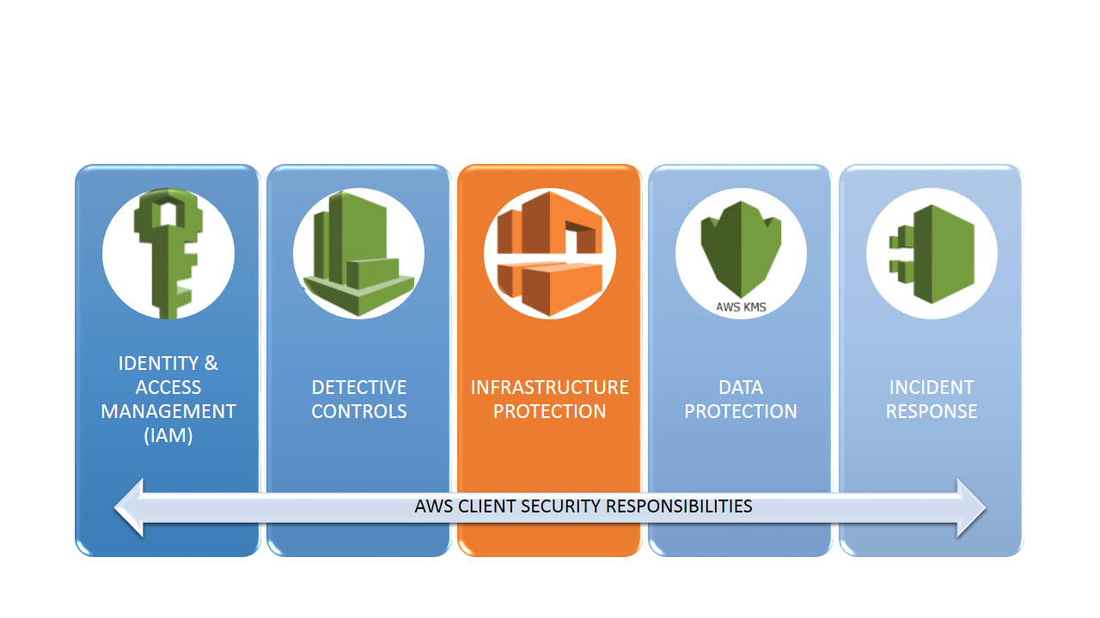

Infrastructure Protection
AWS breaks Infrastructure Protection down into three broad categories:
- Protecting network and host-level boundaries.
- System security configuration and maintenance.
- Enforcing service-level protection.

Protecting Network and Host-Level Boundaries

VPCs
Amazon Virtual Private Cloud (Amazon VPC) allows you to define your network topology that spans an AWS Region with a private IP address range you determine.
Within a VPC, you can create subnets in one or more Availability Zones. Each subnet has an associated route table that defines routing rules for managing the paths that traffic within the subnet takes. You can define a publicly routable subnet by having a route that goes to an internet gateway, a NAT Gateway, or a Customer Gateway attached to the VPC. The absence of a route to the internet gateway prevents instances from being directly reachable.
A subnet can also have an NACL (Network Access Control List) attached to it. Unlike Security groups, which allow outbound traffic by default, you can configure NACL’s to limit both inbound and outbound traffic. Last, AWS has implemented the concept of VPC gateways. A VPC endpoint enables you to privately connect your VPC to supported AWS services and VPC endpoint services powered by PrivateLink without requiring an internet gateway, NAT device, VPN connection, or AWS Direct Connect connection. Instances in your VPC do not require public IP addresses to communicate with other resources. In addition, traffic between your VPC and the other service or resource does not leave the Amazon network.
When a host is launched within a VPC, it normally adopts the security group of the VPC. Security groups act like one-way stateful firewalls. Moreover, you can also define relationships between security groups. For example, instances within a database tier security group can be configured to only accept traffic from instances within a related specific application tier.

Security Groups for EC2-VPC
When you launch an instance in a VPC, you must specify a security group that's created for the VPC. Security groups for EC2-VPC have additional capabilities that aren't supported by security groups for EC2-Classic (Hint: EC2 classic is going away soon, hopefully).
After you launch an instance in a VPC, you can change the security groups that affect it. Security groups are associated with network interfaces. Changing an instance's security groups changes the security groups associated with the primary network interface (eth0). You can also change the security groups associated with any other primary or secondary network interface.
Your VPC can be enabled for IPv6 (IPv6 is not enabled by default). If it is enabled, you can add rules to your VPC security groups to enable inbound and outbound IPv6 traffic as well. To my mind, correct security group configuration is the most important element in securing your EC2 instances.
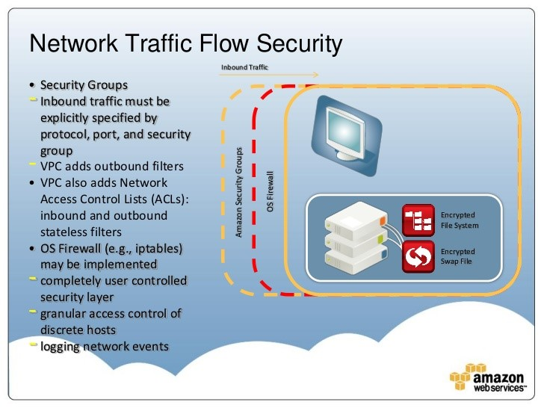
VPC Security Components

Security Group Rules
The rules of a security group control the inbound traffic that's allowed to reach the instances that are associated with the security group and the outbound traffic that's allowed to leave them.
The following are the characteristics of security group rules:
- By default, security groups allow all outbound traffic.
- You can't change the outbound rules for an EC2-Classic security group.
- Security group rules are always permissive; you can't create rules that deny access.
- Security groups are stateful — if you send a request from your instance, the response traffic for that request is allowed to flow in regardless of inbound security group rules. For VPC security groups, this also means that all responses to allowed inbound traffic are allowed to flow out, regardless of outbound rules (unless prohibited by a NACL).
- You can add and remove rules at any time. Your changes are automatically applied to the instances associated with the security group almost immediately after you initiate the change.

System Security Configuration and Maintenance
AWS Systems Manager allows you to centralize operational data from multiple AWS services and automate tasks across your AWS resources. You can create logical groups of resources such as applications, different layers of an application stack, or production versus development environments. Systems Manager provides a central place to view and manage your AWS resources, so you can have complete visibility and control over your operations.

AWS Systems Manager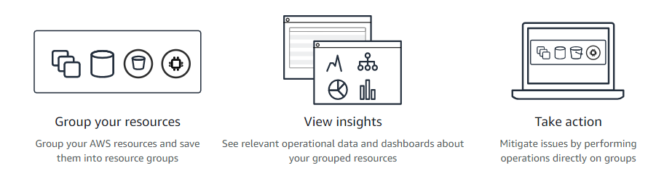

Amazon Inspector
Amazon Inspector is an automated security assessment service that helps improve the security and compliance of applications deployed on AWS. Amazon Inspector automatically assesses applications for vulnerabilities or deviations from best practices. After performing an assessment, Amazon Inspector produces a detailed list of security findings prioritized by level of severity. These findings can be reviewed directly or as part of detailed assessment reports which are available via the Amazon Inspector console or API.

AWS Systems Manager Patch Manager
AWS Systems Manager Patch Manager automates the process of patching managed instances with security-related updates. For Linux-based instances, you can also install patches for non-security updates. You can patch fleets of Amazon EC2 instances or your on-premises servers and virtual machines (VMs) by operating system type. This includes supported versions of Windows, Ubuntu Server, Red Hat Enterprise Linux (RHEL), SUSE Linux Enterprise Server (SLES), and Amazon Linux. You can scan instances to see only a report of missing patches, or you can scan and automatically install all missing patches.

Enforcing Service-Level Protection
You can protect AWS service endpoints by defining policies using IAM. See Part 1 of this series for information on IAM. IAM can help you define policies for access to services and operations. However, for some services, you can also define fine-grained controls to specific resources within those services. Additionally, some resources have their own resource-level policies.
For example, Amazon S3 has bucket policies to define access levels to objects and/or entire buckets, and AWS KMS has policies to define administrators and users of the keys in AWS KMS. Use IAM and resource policies to define a robust protection scheme for your resources.

AWS Key Management Service (KMS)
AWS Key Management Service (KMS) is a managed service that makes it easy for you to create and control the encryption keys used to encrypt your data and uses FIPS 140-2 validated hardware security modules to protect the security of your keys. AWS Key Management Service is integrated with most other AWS services to help you protect the data you store with these services. AWS Key Management Service is also integrated with AWS CloudTrail to provide you with logs of all key usage to help meet your regulatory and compliance needs.
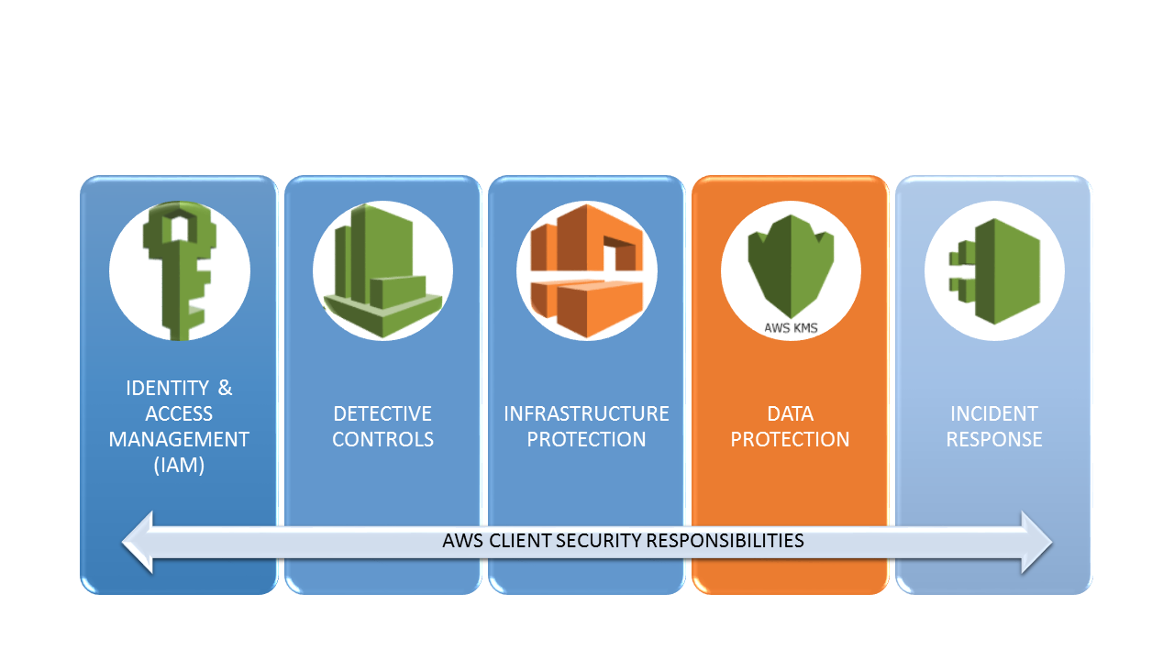

Data Protection
In AWS, there are a number of different approaches to consider when addressing data protection. They are:
- Data classification.
- Encryption/tokenization.
- Protecting data at rest.
- Protecting data in transit.
- Data backup/replication/recovery.

Data Classification
Data classification provides a way to categorize organizational data based on levels of sensitivity. This includes understanding what data types are available, where the data is located, and access levels and protection of the data (for example, through encryption access control). By carefully managing an appropriate data classification system along with each tier’s protection requirements, you can map the controls and level of access/protection appropriate to the data. For example, public-facing content is available for anyone to access, whereas critical content is encrypted and stored in a protected manner.
Understanding and using resource tags is often ignored by AWS users but they are a simple and powerful method of organizing your AWS assets. My number one recommendation to new users of AWS is:
***Take advantage of Resource Tagging***
Tags enable you to categorize your AWS resources in different ways, for example, by purpose, owner, cost center, or environment. Each tag consists of a key and an optional value, both of which you define.
AWS recommends that you devise a set of tag keys that meets your needs for each resource type. Using a consistent set of tag keys makes it easier for you to manage your resources. You can search and filter the resources based on the tags you add.
The following diagram illustrates how tagging works. Tags are simply key:value pairs. In this example, you've assigned two tags to each of your instances, one called Owner and another called Stack. Each of the tags also has an associated value.
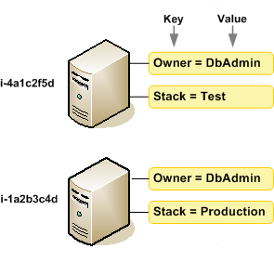
Tags don't have any semantic meaning and are interpreted strictly as a string of characters. Also, tags are not automatically assigned to your resources. You can edit tag keys and values, and you can remove tags from a resource at any time. If you add a tag that has the same key as an existing tag on that resource, the new value overwrites the old value. If you delete a resource, any tags for the resource are also deleted.
Besides resource tags, the primary data classification tools offered by AWS are:

Amazon Macie
Amazon Macie is a security service that uses machine learning to automatically discover, classify, and protect sensitive data in AWS. Macie recognizes sensitive data such as personally identifiable information (PII) or intellectual property and provides you with dashboards and alerts that give visibility into how this data is being accessed or moved. Amazon Macie continuously monitors data access activity for anomalies and delivers alerts when it detects the risk of unauthorized access or inadvertent data leaks.
Three other tools that are useful for aggregating and monitoring resources have already been mentioned. These are AWS Systems Manager, AWS Config, and Service Manager.

Encryption/Tokenization
Data protection refers to protecting data while in-transit (as it travels to and from Amazon S3) and at rest (while it is stored on disk in Amazon S3).
AWS uses a dual key approach to encrypting most data: Customer Master Keys (CMKs) and Data Keys (DKs). A high-level diagram is shown below.
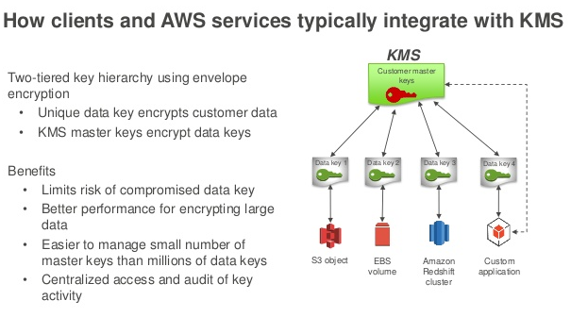

Customer Master Keys
The primary resources in AWS KMS are customer master keys (CMKs). You can use a CMK to encrypt and decrypt up to 4 kilobytes (4096 bytes) of data at a time. Typically, you use CMKs to generate, encrypt, and decrypt the data keys that you use outside of AWS KMS to encrypt your data.
AWS KMS stores, tracks, and protects your CMKs. When you want to use a CMK, you access it through AWS KMS. CMKs never leave AWS KMS unencrypted. This strategy differs from data keys that AWS KMS returns to you, optionally in plaintext. AWS KMS does not store, manage, or track your data keys.
There are two types of CMKs in AWS accounts:
- Customer-managed CMKs are CMKs that you create, manage, and use.
- AWS managed CMKs are CMKs in your account that are created, managed, and used on your behalf by an AWS service that is integrated with AWS KMS.

Data Keys
Data keys are encryption keys that you can use to encrypt data, including large amounts of data and other data encryption keys. You can use your AWS KMS CMKs to generate, encrypt, and decrypt data keys, but AWS KMS does not store, manage, or track your data keys, and AWS KMS cannot use a data key to encrypt data for you. You must use and manage data keys inside your application.

Envelope Encryption
AWS KMS uses envelope encryption to protect data. Envelope encryption is the practice of encrypting plaintext data with a unique data key, and then encrypting the data key with a key encryption key (KEK).
The key AWS service that supports encryption is AWS KMS, which provides an easy-to-use, secure, and redundant key management service. The following service is also important:
- AWS CloudHSM provides a hardware security module for managing keys.
AWS Key Management Service (KMS): AWS KMS allows you to centrally manage and securely store your keys. You can generate keys in AWS KMS or import them from your key management infrastructure. These keys can be used from within your applications and supported AWS services to protect your data, but the key never leaves AWS KMS. You set usage policies on these keys that determine which users can use them to encrypt and decrypt data. All requests to use these keys are logged in AWS CloudTrail so you can understand who used which key when.
AWS CloudHSM is a cloud-based hardware security module (HSM) that enables you to easily generate and use your own encryption keys on the AWS Cloud. With CloudHSM, you can manage your own encryption keys using FIPS 140-2 Level 3 validated HSMs.

Securing Data at Rest
Data at rest includes inactive data that is stored physically in any digital form (e.g. databases, data warehouses, spreadsheets, archives, tapes, off-site backups, mobile devices, etc.). Multiple AWS services provide built-in integration with AWS KMS to allow easy encryption of your persistent storage. These include Server Side Encryption for Amazon S3 and Amazon Glacier, multiple tiers of encryption for Amazon Redshift, and Transparent Data Encryption for Oracle and SQL Server databases via Amazon RDS. Moreover, you can now encrypt data stored on an EBS volume at rest and in motion by setting a single option. When you create an encrypted EBS volume and attach it to a supported instance type, data on the volume, disk I/O, and snapshots created from the volume are all encrypted. The most typical use case for data-at-rest encryption is encryption of S3 buckets. You have two options for this:
- Use Server-Side Encryption – You request Amazon S3 to encrypt your object before saving it on disks in its data centers and decrypt it when you download the objects.
- Use Client-Side Encryption – You can encrypt data client-side and upload the encrypted data to Amazon S3. In this case, you manage the encryption process, the encryption keys, and related tools.
You also have the option of implementing your own encryption-at-rest approach. For example, you can encrypt content locally and store encrypted content. Amazon S3 provides you the facility to upload an already encrypted object. It also provides the ability for you to upload an object along with an encryption key that’s used in-memory to encrypt an object. To retrieve the object, you must supply the same key.
The key AWS service that protects data at rest is AWS KMS, which provides an easy-to-use, secure, redundant, key management service. The following services are also components of the AWS strategy for protecting Data-at-Rest:
- Amazon S3 provides an object storage service that integrates with AWS KMS and allows you to supply your own keys. You can securely upload or download your data to Amazon S3 via the SSL-encrypted endpoints using the HTTPS protocol. Amazon S3 can automatically encrypt your data at rest and gives you several choices for key management. You can configure your S3 buckets to automatically encrypt objects before storing them in S3 if the incoming storage requests do not have the encryption information.
- Amazon EBS provides block storage integrated with AWS KMS. You can perform block-level encryption with your own operating system tools or third-party solutions. You can now encrypt data stored on an EBS volume by setting a single option. When you create an encrypted EBS volume and attach it to a supported instance type, data on the volume, disk I/O, and snapshots created from the volume are all encrypted. The encryption occurs on the servers that host the EC2 instances, providing encryption of data as it moves between EC2 instances and EBS storage.
- Amazon Glacier handles key management and key protection for you. Amazon Glacier uses one of the strongest block ciphers available, 256-bit Advanced Encryption Standard. In addition, if you want to (or are mandated to) manage your own keys, you can encrypt data prior to uploading it. Glacier has recently added Vault Lock. This new feature allows you to lock your vault with a variety of compliance controls that are designed to support such long-term records retention. You can now create a Vault Lock policy on a vault, and after it is locked, the policy cannot be overwritten or deleted.

Securing Data in Transit
Data in transit is any data that gets transmitted from one system to another. This includes communication between servers within your environment as well as communication between other services and your end users. By providing the appropriate level of protection for your data in transit, you protect the confidentiality of your application’s content. When protecting your data in transit, selecting protocols that implement the latest version of Transport Layer Security (TLS) is a common best practice.
AWS services provide many HTTPS endpoints for communication, thus providing encryption in transit when communicating with the AWS APIs. You have full control over your computing resources to implement encryption in transit across your services. Additionally, the AWS Certificate Manager (ACM) service provides you the ability to manage and deploy certificates for your domains.
Additionally, you can leverage VPN connectivity into your VPC or across your VPCs to facilitate encryption of traffic. When planning for an encryption-in-transit approach, consider your use cases and the balance between encryption and ease of use. Consider the use of VPN connectivity from your data center to AWS and look into HTTPS for secure application-to-application communication.
The key AWS service that protects data in transit is ACM, which helps you generate certificates used for establishing encrypted transport between systems.
AWS Certificate Manager (ACM) is a service that lets you easily provision, manage, and deploy public and private Secure Sockets Layer/Transport Layer Security (SSL/TLS) certificates for use with AWS services and your internal connected resources. SSL/TLS certificates are used to secure network communications and establish the identity of websites over the Internet as well as resources on private networks.
The following services and features also play a role in encrypting Data in Transit:
- ELB Load Balancers help deploy and manage load balancers using secure endpoints. One of the most important capabilities of the load balancer is its ability to perform SSL offload. In order to do SSL offload, the load balancer needs a certificate attached to one or more secured listeners. Elastic Load Balancing has recently been integrated with ACM to provision, manage, and deploy Secure Sockets Layer/Transport Layer Security (SSL/TLS) certificates. This allows seamless provisioning of ELBs with the required certificates.
- Amazon CloudFront supports encrypted endpoints for your content distributions. For web distributions, you can configure CloudFront to require that viewers use HTTPS to request your objects, so connections are encrypted when CloudFront communicates with viewers. You also can configure CloudFront to use HTTPS to get objects from your origin, so connections are encrypted when CloudFront communicates with your origin.
- AWS Shield is a managed Distributed Denial of Service (DDoS) protection service that safeguards applications running on AWS. AWS Shield provides always-on detection and automatic inline mitigations that minimize application downtime and latency, so there is no need to engage AWS Support to benefit from DdoS protection

Data Backup/Replication/Recovery
“If you store 10,000 objects with us, on average we may lose one of them every 10 million years or so. This storage is designed in such a way that we can sustain the concurrent loss of data in two separate storage facilities.” - Amazon
AWS provides you with multiple features and capabilities around data backup and replication. Amazon S3 is designed for 11 nines of durability for objects stored in the service, and it allows you to create copies of the content that can be replicated to other locations and AWS accounts for additional protection.
Amazon RDS performs snapshots or backups of your DB instances and allows you to replicate those instances to other locations. Snapshots can be taken of EBS volumes and copied across Regions. Additionally, you can automate tasks and scheduled jobs to perform backups of resources. Consider using a Lambda function to issue backups at an interval using CloudWatch Events.
Amazon Glacier is a secure, durable, and extremely low-cost cloud storage service for data archiving and long-term backup. Use this service for cost-effective storage of backup copies. These copies can be retrieved when needed for recovery, whether it’s for testing, compliance issues, or disaster scenarios.
The key AWS service that supports data backup, replication and recovery is Amazon S3. The following services and features are also important for backup and replication of data:
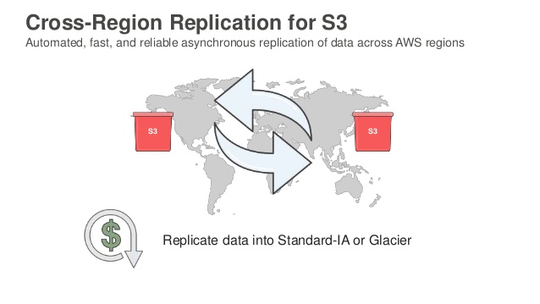
Amazon S3 Cross-Region Replication (CRR) is an Amazon S3 bucket-level feature that enables automatic, asynchronous copying of objects across buckets in different AWS Regions. Once enabled, every object uploaded to a particular S3 bucket is automatically replicated to a designated destination bucket located in a different AWS region. You can enable and start using this feature by simply enabling versioning. With versioning enabled, the rest is easy. You simply choose the destination region and bucket (and optionally restrict replication to a subset of the objects in the bucket using a prefix), set up an IAM role, and you are done.
Amazon S3 Lifecycle Policies and Versioning allow you to implement a backup strategy and meet retention requirements. You can use lifecycle policies to define actions you want Amazon S3 to take during an object's lifetime (for example, transition objects to another storage class, archive them, or delete them after a specified period of time). You can define a lifecycle policy for all objects or a subset of objects in the bucket by using a shared prefix (that is, objects that have names that begin with a common string).
Amazon EBS Snapshots let you back up your volumes attached to EC2 instances. You can back up the data on your Amazon EBS volumes to Amazon S3 by taking point-in-time snapshots. Snapshots are incremental backups, which means that only the blocks on the device that have changed after your most recent snapshot are saved. This minimizes the time required to create the snapshot and saves on storage costs by not duplicating data.
This concludes the section on AWS native data protection services. When implementing encryption-at-rest and encryption-in-transit protection, consider the data classification model for your organization to ensure that the degree of data protection reflects your internal requirements. Additionally, you should consider any compliance or regulatory requirements. The key point here is that AWS provides mechanisms that allow you to apply encryption ubiquitously.
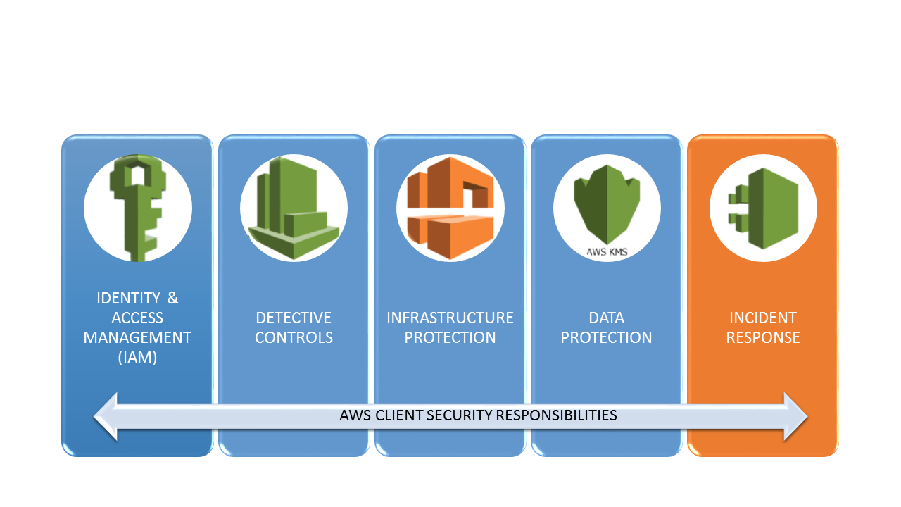

Incident Response
At first glance, incident response within AWS may appear more challenging than incident response in an on-premise environment. Not only are servers not physically available, but techniques associated with virtual machines such as taking a full disk and memory snapshot are not available. However, by leveraging the APIs provided by AWS, organizations can prepare themselves to automatically collect evidence and mitigate compromises of AWS instances. Before implementing such a solution, the organization should understand what preparations need to be made, mitigations need to be performed, and what evidence needs to be collected.
Before an incident ever occurs, an organization should ensure it has adequately prepared to deal with an incident. Determine the access your first responders need ahead of time, and then regularly verify the access is functional - or easily triggered - when needed. The two crucial response areas an organization should address include strengthening existing or available defenses to reduce the attack surface and increasing the organization’s ability to detect, remediate, and prevent future attacks. As we have already mentioned, AWS has many native security and monitoring services to assist in meeting these objectives, including CloudWatch, CloudTrail, Config, and IAM.
By using resource tags to properly describe your AWS resources, incident responders can quickly determine the potential impact of an incident. For example, tagging instances and other assets with an owner or work queue allows the team to engage relevant people more quickly. Moreover, by tagging systems with a data classification or a criticality attribute, the impact of an incident can be estimated more accurately.
For capturing the disk image or "as-is" configuration of an operating system, you can use EBS snapshots and the Amazon EC2 APIs to capture the data and state of systems under investigation. Storing snapshots and related incident artifacts in Amazon S3 or Amazon Glacier ensures that the data will be available and retained as appropriate.
During an incident, before the root cause has been identified and the incident has been contained, it can be difficult to conduct investigations in an untrusted environment. Unique to AWS, security practitioners can use CloudFormation to quickly create a new, trusted environment in which to conduct a deeper investigation.
The CloudFormation template can pre-configure instances in an isolated environment that contains all the necessary tools forensic teams need to determine the cause of the incident. This cuts down on the time it takes to gather necessary tools, isolates systems under examination, and ensures that the team is operating in a clean room.

Conclusion
Security is hard. We all know that. When an incident occurs it should be treated as an opportunity to improve the security of your infrastructure. AWS provides a spectrum of mechanisms for protecting data. Strong authentication and authorization controls, automated responses to security events, simple, cost-effective monitoring of systems and API calls, protection of infrastructure at multiple levels, and ubiquitous protection of data with encryption provide a level of defense-in-depth security controls that most organizations only aspire to.

